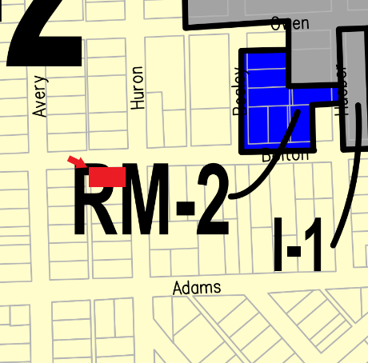
March 21, 2023

TO: Occupant
FROM: City of Alpena
RE: Notice of Rezoning Application within 300 feet

This letter is to notify you that a property owner within 300 feet of your property has applied for a conditional rezoning. Public Act 110 of 2006, as amended, requires notification of all property owners within 300 feet of the boundary of a property for which a rezoning has been applied. Your property is within 300 feet of the following:

Rezoning Applicant: Debra S Pernie
Address: 312 Huron St
Rezoning: Conditional Map Amendment request from R-2 (Single-Family District) to R-T (Two-Family District) to allow the home to be utilized as a duplex.

The City of Alpena Planning Commission will hold a public hearing on April 11, 2023 at 6:00 pm at 208 N. First Avenue, Alpena, Michigan 49707. Written comments may be sent to the above address prior to the meeting or to my e-mail below. The public may appear at the public hearing in person, by counsel, or virtually. The proposed rezoning documents can be accessed at City Hall, at https://alpena.mi.us, or by calling 989-354-1700.

Virtual Meeting Option:
https://www.gotomeet.me/CityofAlpena/planning-commission
You can also dial in using your phone.
United States: +1 (571) 317-3112
Access Code: 178-564-461

Sincerely,
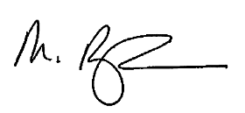
Montiel Birmingham
Planning, Development, and Zoning Director
208 North First Avenue
Alpena, MI 49707
989.354.1771
montielb@alpena.mi.us

