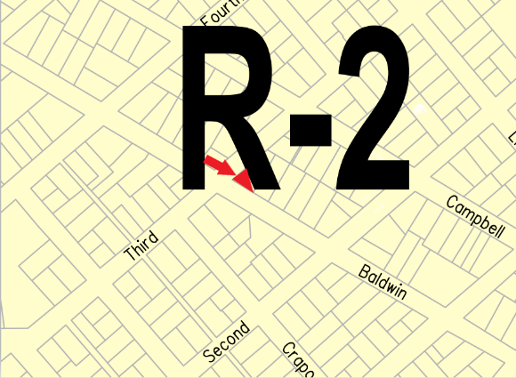
November 28, 2022

TO: Occupant
FROM: City of Alpena
RE: Notice of Zoning Board of Appeals permit applicant within 300 feet

This letter is to notify you that a property owner within 300 feet of your property has applied for a Dimensional Variance with the Zoning Board of Appeals. Public Act 110 of 2006, as amended, requires notification of all property owners within 300 feet of the boundary of a property for which a variance has been applied. Your property is within 300 feet of the following:

ZBA Applicant: Barbara & Arthur Romel
Address: 139 W Baldwin St
Variance Permit Purpose: Applicant requests a dimensional variance for a reduced side setback for a carport and a lot coverage variance to construct a covered porch.

The City of Alpena Zoning Board of Appeals will hold a public hearing on December 21, 2022 at 5 pm at 208 N. First Avenue, Alpena Michigan 49707. Written comments may be sent to the above address prior to the meeting, attention to the Planning, Development, and Zoning Director. The public may appear at the public hearing in person, virtually, or by counsel. The proposed ZBA documents can be accessed at City Hall, at https://alpena.mi.us/, or by calling 989-354-1700.

Virtual Meeting Option:
https://meet.goto.com/CityofAlpena/zoning-board-of-appeals
You can also dial in using your phone.
United States: +1 (571) 317-3122
Access Code: 788-887-717
Sincerely,
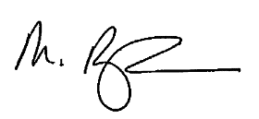
Montiel Birmingham
Planning, Development, and Zoning Director
989.354.1771
montielb@alpena.mi.us

